2023 Midsem
- Give three adaptive features of camels in to desert environment
- What is the adaptive significance of dark plumage on the birds of the desert
- What is the purpose of the erection of feathers in birds
- In the body's mechanism in the regulation of glucose, the functions of the digestive, circulatory and endocrine systems
- What is the difference between phenotypic plasticity and phenotypic flexibility
- What is adaptation and state the forms if any
- Explain positive and negative feedback responses and explain the physiological processes of any of them
- State the 3 ways of measuring adaptation. State the most suitable and the disadvantages of its use
- Fill in the spaces and give examples
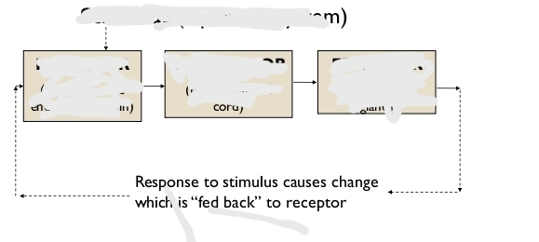

End Of Sem
Midsem questions repeated
Write short notes on the thermal counter-current system of mammals

